**ARDUINO BASE BOARD DETAILS**

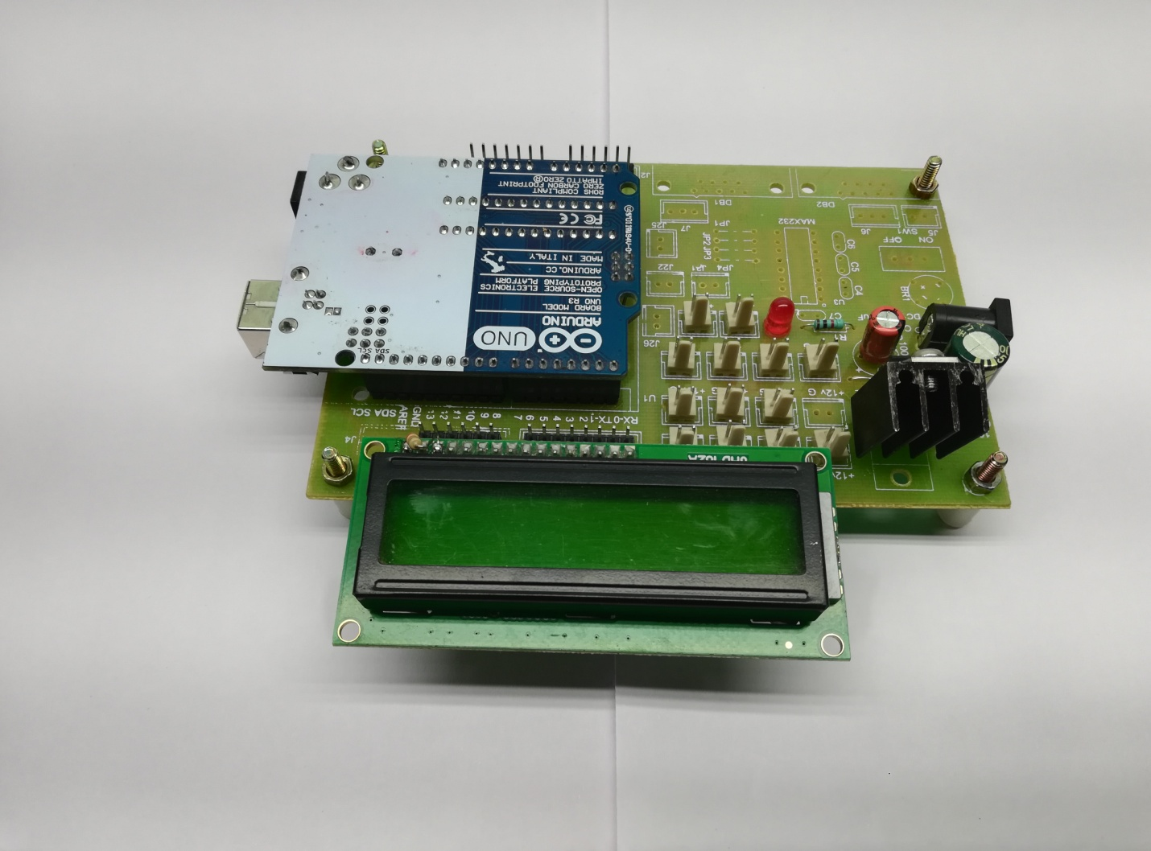

* 16*2 Lcd Display =01
* Dc Female Socket =01
* 1000/25v Capacitors =01
* 100/25v Capacitors =01
* 7805 Regulators =01
* 5mm Red Led =01
* 2pin Male Connectors=As Per Our ReQ
* Uno Base Board =01
* 1 K Resistor =01
* Male Bucks =01
* Female Bucks =01
* Arduino Micro Controller =01